|  |  |  |  |  |
| --- | --- | --- | --- | --- |
| **INTERSTATE CONTAINER CORPORATION** | | | ***Date:* 08/23/2016** | ***Spec #:*** |
| ***Customer:*** | **DeMet's Candy** |  |  |  |
| ***Description:*** | **SHIPPER - RSC.474/0 - WalMart - 474 Jigsaw hearts 2x6=12ct [Lefthand 1/4"gap]** | | | |
| ***Style:* RSC 1/4 GAP** |  | ***Revision Info:* [0] 07/12/2016:** |  |  |
| ***I.D. :* 18+1/8 x 9+1/16 x 12+1/2** | | ***Blank size:* 21+11/16 x 56+1/8** |  |  |
| ***Board:* 32 B K** |  | ***Combination:* 35HP - 23M - 35HP** | ***Designer:* Doug Bowers** |  |
| **FL924** | |  |  |  |

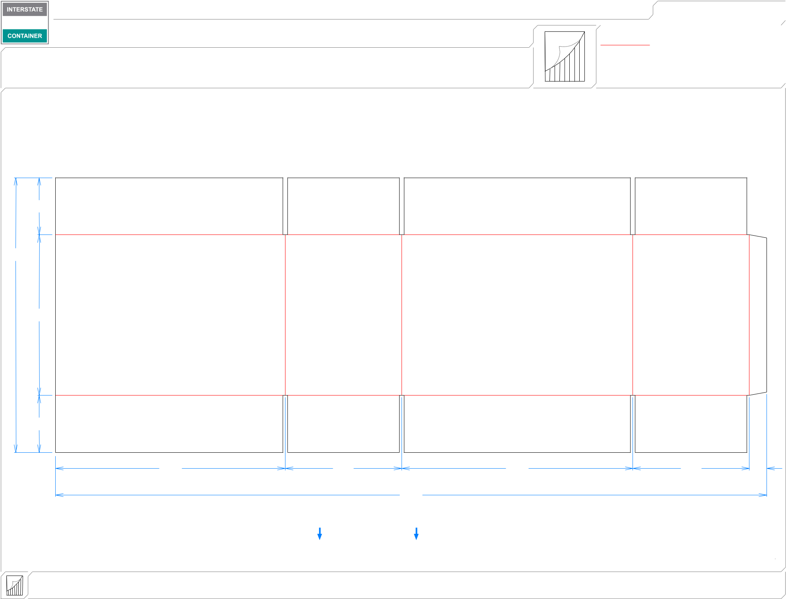

|  |  |  |  |  |
| --- | --- | --- | --- | --- |
| ***Design #:*** | | **160835-03** |  |  |
|  |  |  |
|  |  |  |  |  |
|  | ***Cut*** | **210 in.** | |  |
|  |  |
|  | ***Crease*** | **158 in.** | |  |
|  |  |  |  |  |

41*/*2

2111*/*16

1211*/*16

|  |  |  |  |  |
| --- | --- | --- | --- | --- |
| 41*/*2 |  |  |  |  |
| 181*/*8 | 93*/*16 | 181*/*4 | 93*/*16 | 13*/*8 |
|  |  | 561*/*8 |  |  |

**LEAD EDGE**

|  |  |  |  |
| --- | --- | --- | --- |
| **inside view** | ***notes:*** |  |  |
| **Vertical Corrugation** | ***Qty/unit:* 1 PER DISPLAY *Area - waste:* 8.28 sq. ft** | ***Waste on blank:* 2.0%** | ***Piece weight - waste:* 0.85 lbs./387.41 g** |